**Lab Assignment 3**

This web application is designed to provide user to login through social media like gmail, facebook. It also provides mashup by using different knowledge services and web services. This application contains knowledge service called Alchemy and web services Face + + for face detection and Inlite for bar code scanning

**Wire Frames:**

**Login Page:**

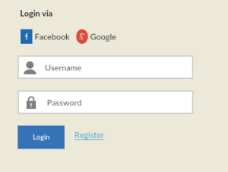

**Welcome Page:**

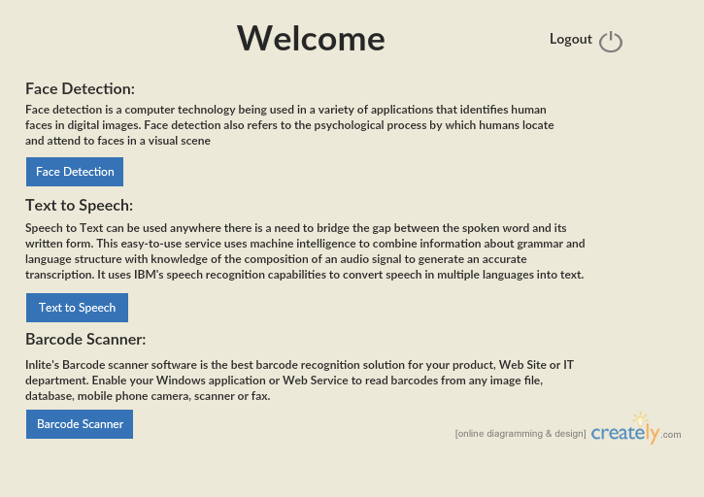

**Face Detection Page:**

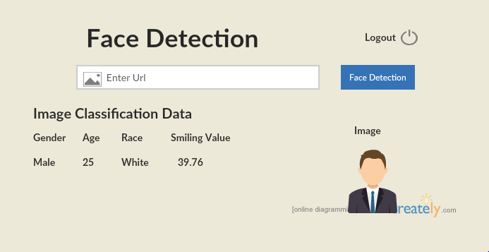

**Text to Speech Conversion Page:**

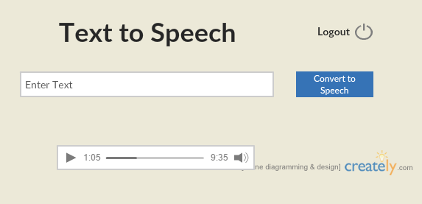

**Barcode Scanner Page:**

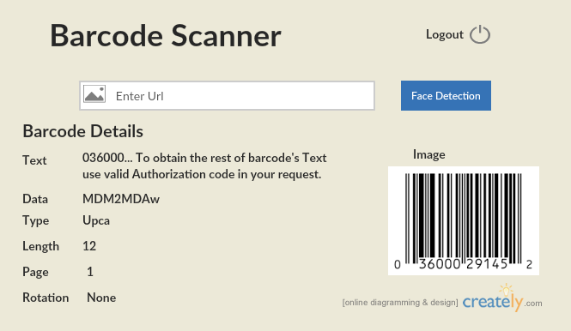

**Web Application Pages:**

**Login Page:**

This is the Login page of the Web Application. This login page two ways of signing in one is if to provide credentials and login and the other is to login using social media accounts like gmail and facebook.

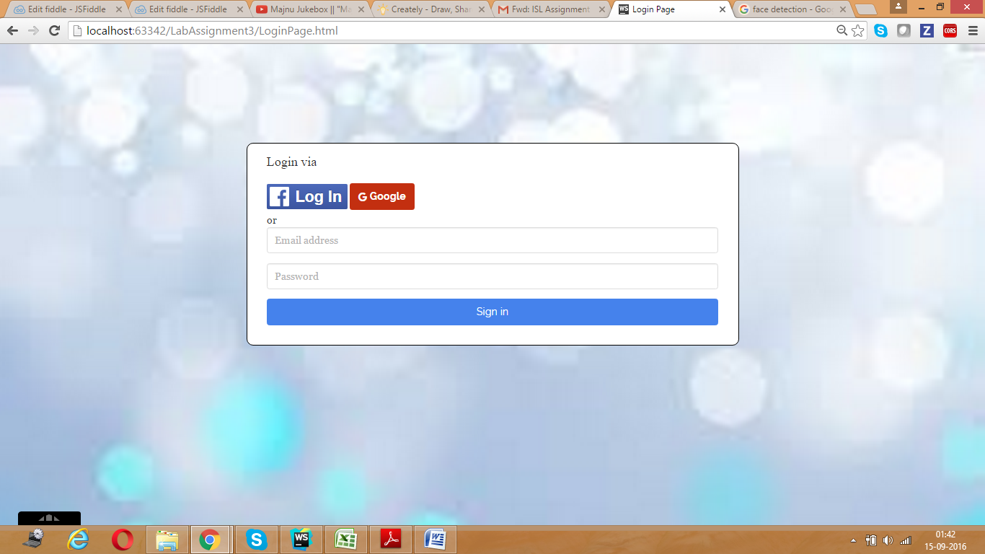

**Facebook Login Page:**

When you click on facebook button it will direct you to the facebook login page where you can provide you facebook credentials and login to this application. After successful login you will be directed to Welcome page.

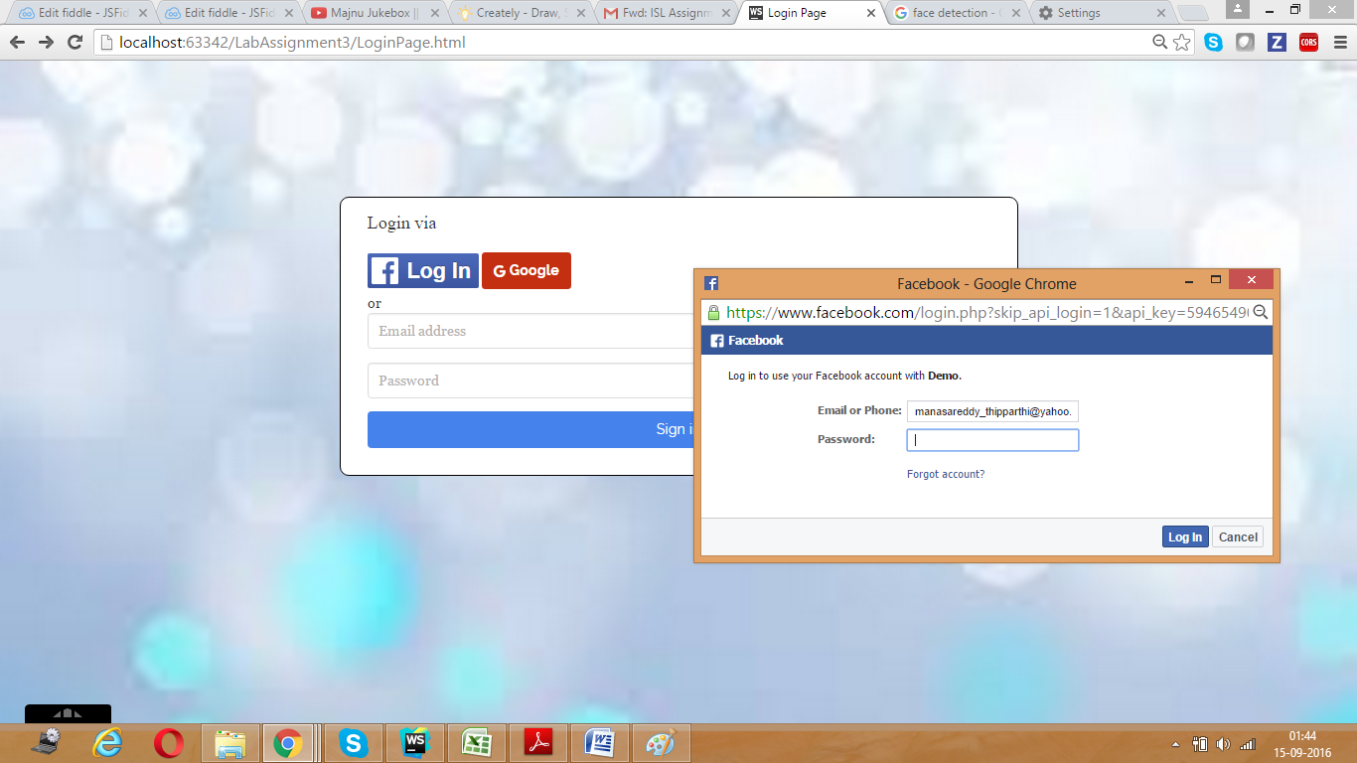

**Gmail Login Page:**

When you click on Google button it will direct you to the gmail login page where you can provide you gmail credentials and login to this application. After successful login you will be directed to Welcome page.

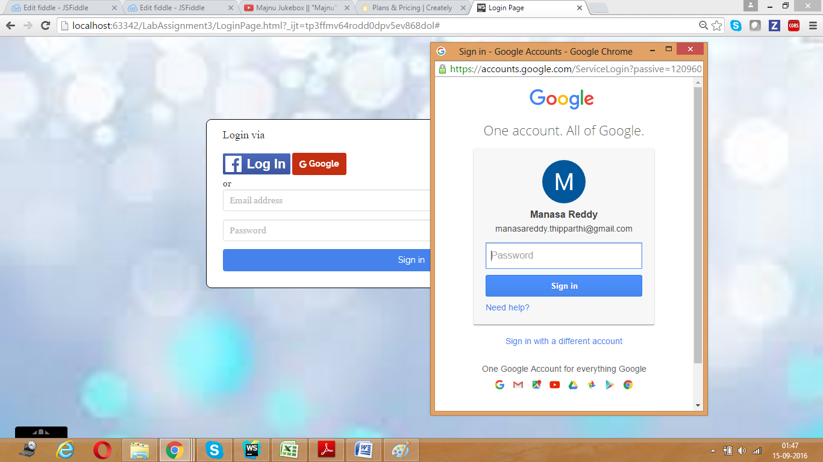

**Welcome page:**

The Welcome page contains the list of functionalities provided in this application that are developed using different knowledge services and web services. A brief description of each and every functionality is provided and also a link to access that particular functionality is also provided.

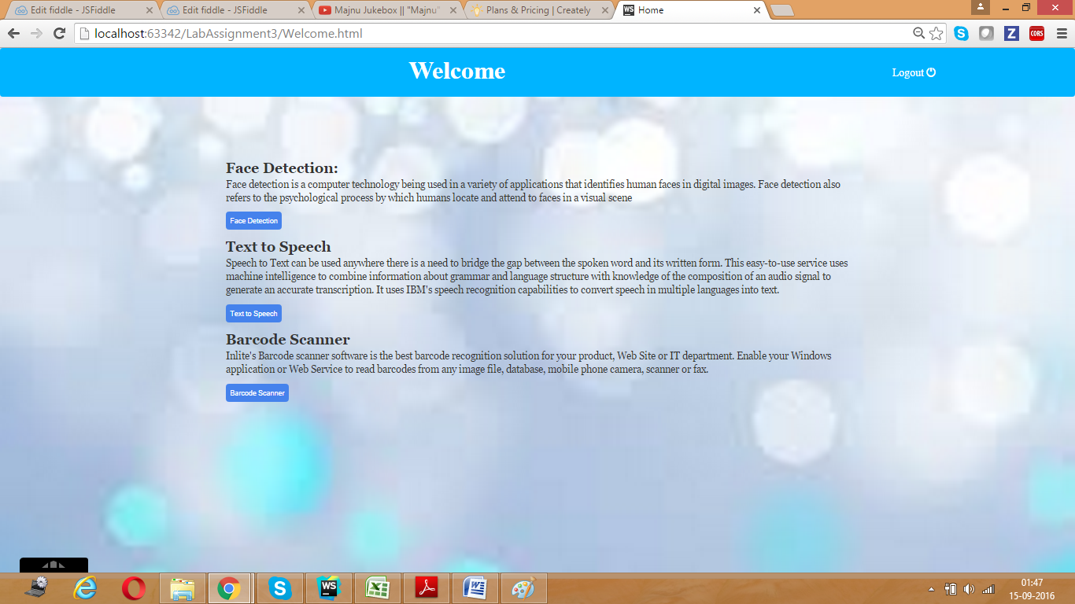

**Face Detection Page:**

Face Detection functionality has been developed by using Face ++ api which takes url of the image as input and detects the number of persons in the image and also gives the information of all the persons present in the image like gender, Age, Race, Smiling value.

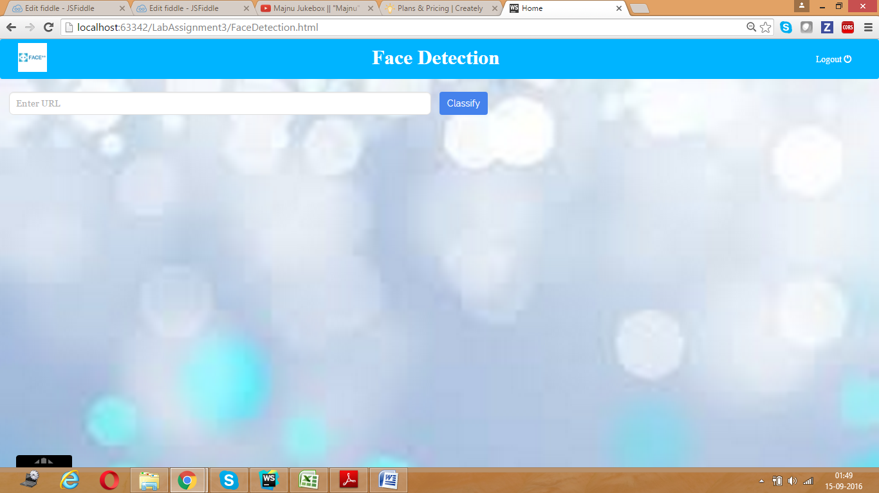

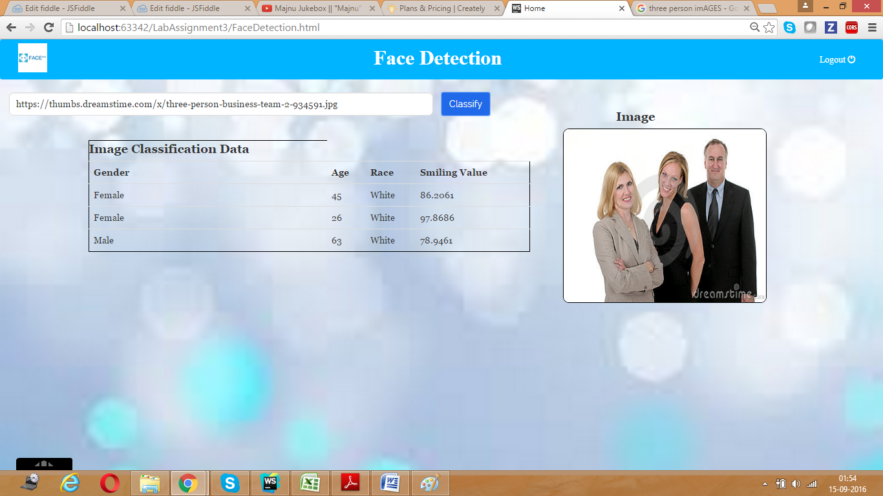

**Text to Speech Conversion Page:**

Text to Speech conversion functionality is developed by using Alchemy api. Which takes text as input and converts it into audio. This audio can be played multiple times and also have an option to pause and play it again.

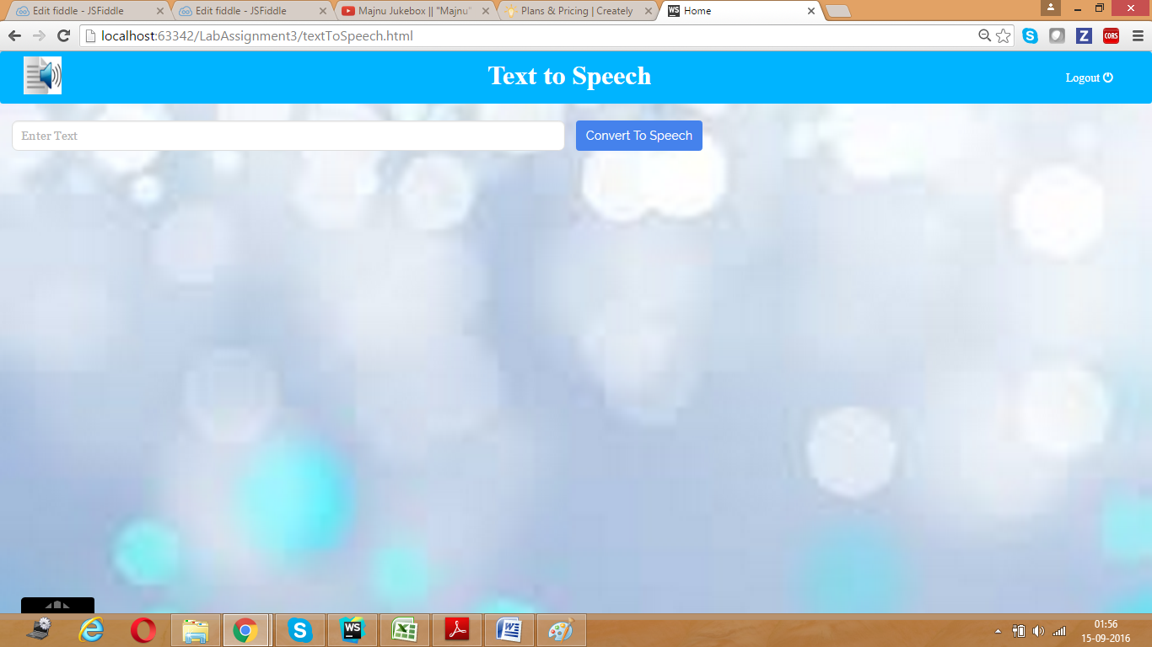

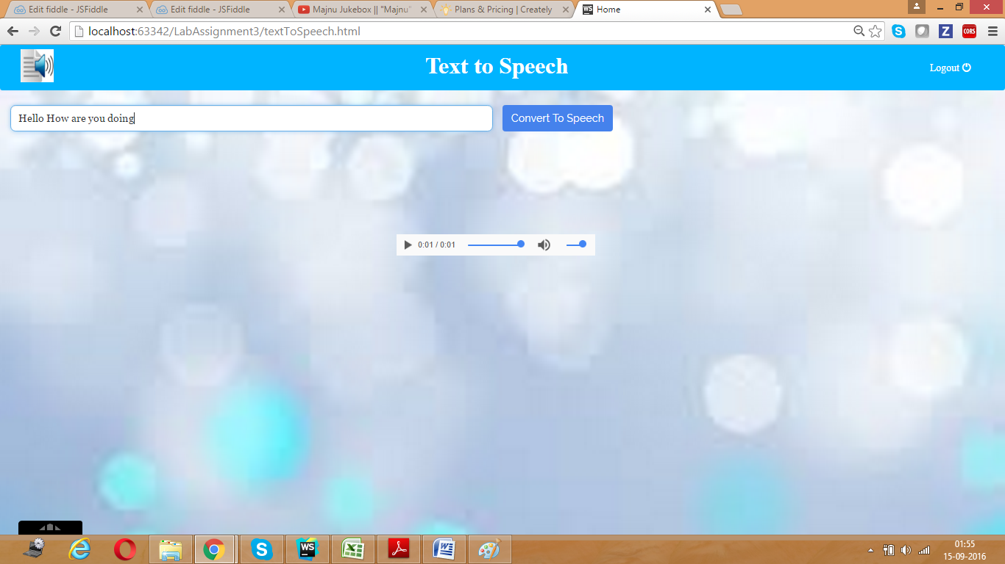

**Barcode Scanner Page:**

Barcode scanner functionality has been developed by using inlite api. Which accepts url of the image having barcode as input and displays the image and data related to the barcode like data, text, type etc

